INC000099314339: RE: (SUCCESS) Zero Payments Customer Accounts Report
5 de dezembro de 2025
10:44
Date: 13-May-2026
Requester: Baptista, Matilde
Assignee: Frederico Araújo
Description:
- Zero Payments Customer Accounts Report (Weekly - every Monday) was not updated for 20260511 (Email reference: dapt_zero_payments). Last update was 04-May.
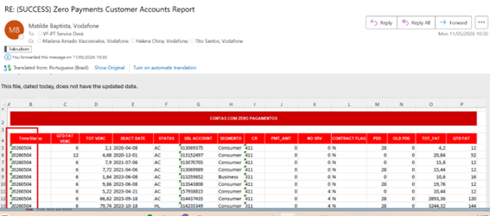

Initial Diagnosis:
- Return Feed process did not run on local side (target table was loaded until 04-May), although GCP table contains data for 11-May (and DAG the reads from the GCP table ran successfully on same day 11).

Actions Taken:
- After confirmed local and GCP tables (initial diagnosis info).
SP:
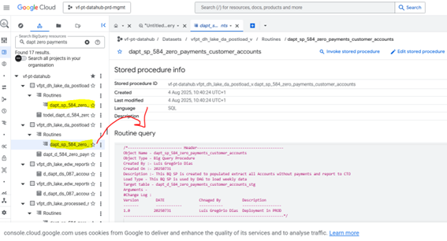
BQ Table updated on 11-May with same day's records.
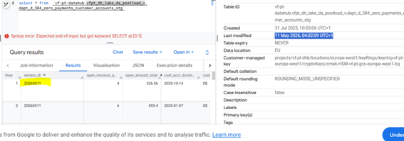

Target table (not yet updated):
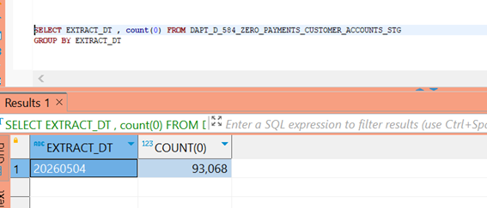

DAG executed on 11-May, as expected (it generates file to send to local environment):
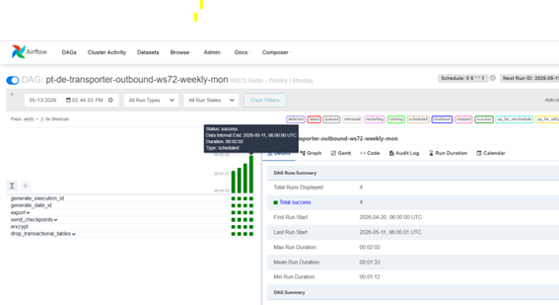

- Checked Confluence page to find the Talend jobs:
https://confluence.sp.vodafone.com/spaces/VDE1/pages/682614150/Talend+-+Job+15+Nucleus+Zero+Payments+Customer+Accounts

- Checked Talend Job - Last run on 04-May:
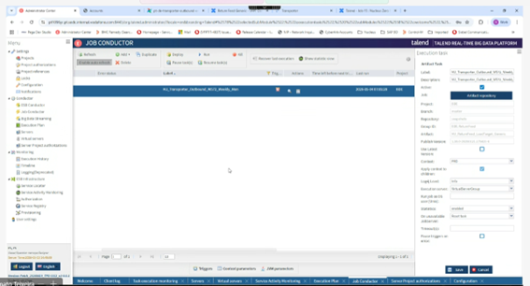

Note: This issue may be related to the Talend instability observed over the past few days (until yesterday, 12).

- Re-ran the DAG to generate again the files to be loaded by process (transposer trigger the Talend jobs for loading and email):
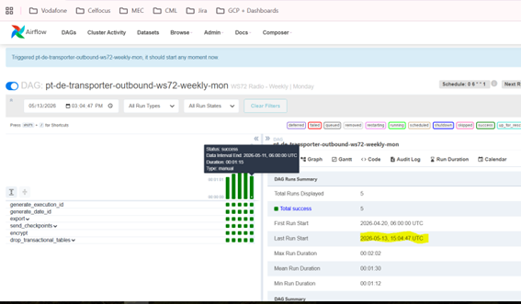

- Confirmed the data has arrived on local target table:
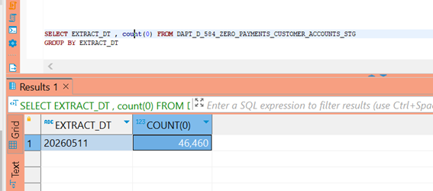

Note: Main queries performed on local side.

- To identify last run performed by the process (before the actions, it was 04-May-2026)
SELECT * FROM talend_bde.ctr_rf_database_loads
WHERE feed LIKE '%dapt%zero%'
ORDER BY LOAD_DATE desc ;

- To check the chain_name (it can be used to find the URL to the GCP DAG) and also the Target Table (or file, not for this feed) where data will be loaded.
SELECT * FROM MTD_RF_FEED_CONF mrfc
WHERE feed_name = 'dapt_d_584_zero_payments_customer_accounts_stg';

- Similar to the previous query, just to check if the DAG runs this feed only. If not, need to evaluate if the files can be sent again to be processed by local jobs. In this case, only this feed was assigned to this chain_name (DAG).
SELECT * FROM MTD_RF_FEED_CONF mrfc
WHERE chain_name = 'ReturnFeed_WS72_W_Monday';

- Parameters to create DB connection - Password is encrypted.
SELECT *
FROM MTD_GLBL_JOB_PARAM a
WHERE cd_job = 'ReturnFeed_WS72_W_Monday'

- To decrypt the password:
SELECT ds_value, talend_crypto.talend_security.decrypt(ds_value)
FROM MTD_GLBL_JOB_PARAM a
WHERE cd_job = 'ReturnFeed_WS72_W_Monday'
AND CD_KEY ='DB_Password'

Resolution:
- DAG was reprocessed by triggering it, and Job processes ran automatically, including that one which emails user after loading completed.

Related Links:
- INC000098883638 RE: Radio - Daily | dapt_performance_roamers (similar issue)
- Confluence:
Talend Jobs: https://confluence.sp.vodafone.com/spaces/VDE1/pages/682614150/Talend+-+Job+15+Nucleus+Zero+Payments+Customer+Accounts
Return Feeds Process (to find out the DAG name / URL):
https://confluence.sp.vodafone.com/spaces/VDE1/pages/688321603/Return+Feed+Generic

